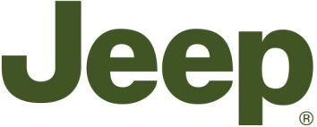

Jeep Grand Cherokee is “2012 SUV of Texas”

Highlights:
- Jeep Grand Cherokee retains “SUV of Texas” title for 2012
- Jeep Grand Cherokee Overland Summit is named “Luxury SUV of Texas” 2012
- Jeep Wrangler is named “Mid-size SUV of Texas” again in 2012
- Dodge Durango scoops “Full-Size SUV of Texas” 2012 award

Press Release:
The Jeep brand, the company that created the all-purpose vehicle decades ahead of its competitors, has done another Texas two-step around other SUV manufacturers during the annual Texas Auto Writers Association's annual “Texas Truck Rodeo”.

For the second year in a row the Jeep Grand Cherokee has been named the “SUV of Texas” title while the Jeep Wrangler Unlimited has also retained its “Mid-size SUV of Texas” again for 2012.

"The Jeep Grand Cherokee has once again demonstrated its superior levels of performance, quality, interior craftsmanship, and reliability that make it an award-winning SUV,” said TAWA President Mike Herzing. "Grand Cherokee is clearly the SUV of Texas."

The range-topping Jeep Grand Cherokee Overland Summit took the “Luxury of SUV of Texas” award, ahead of rivals from Land Rover and Porsche, while the Dodge Durango (not sold in Europe) was named the 2012 Full-Size SUV of Texas."

The “Texas Truck Rodeo” is an annual, two-day evaluation weekend which enables the 57 TAWA members assess a broad variety of vehicles both on and off road. Consideration was given to everything from exterior styling and off-road capability to the vehicles’ overall utility, value and fuel efficiency.
- Ends -

